**USER INTERFACE SCREEN:**

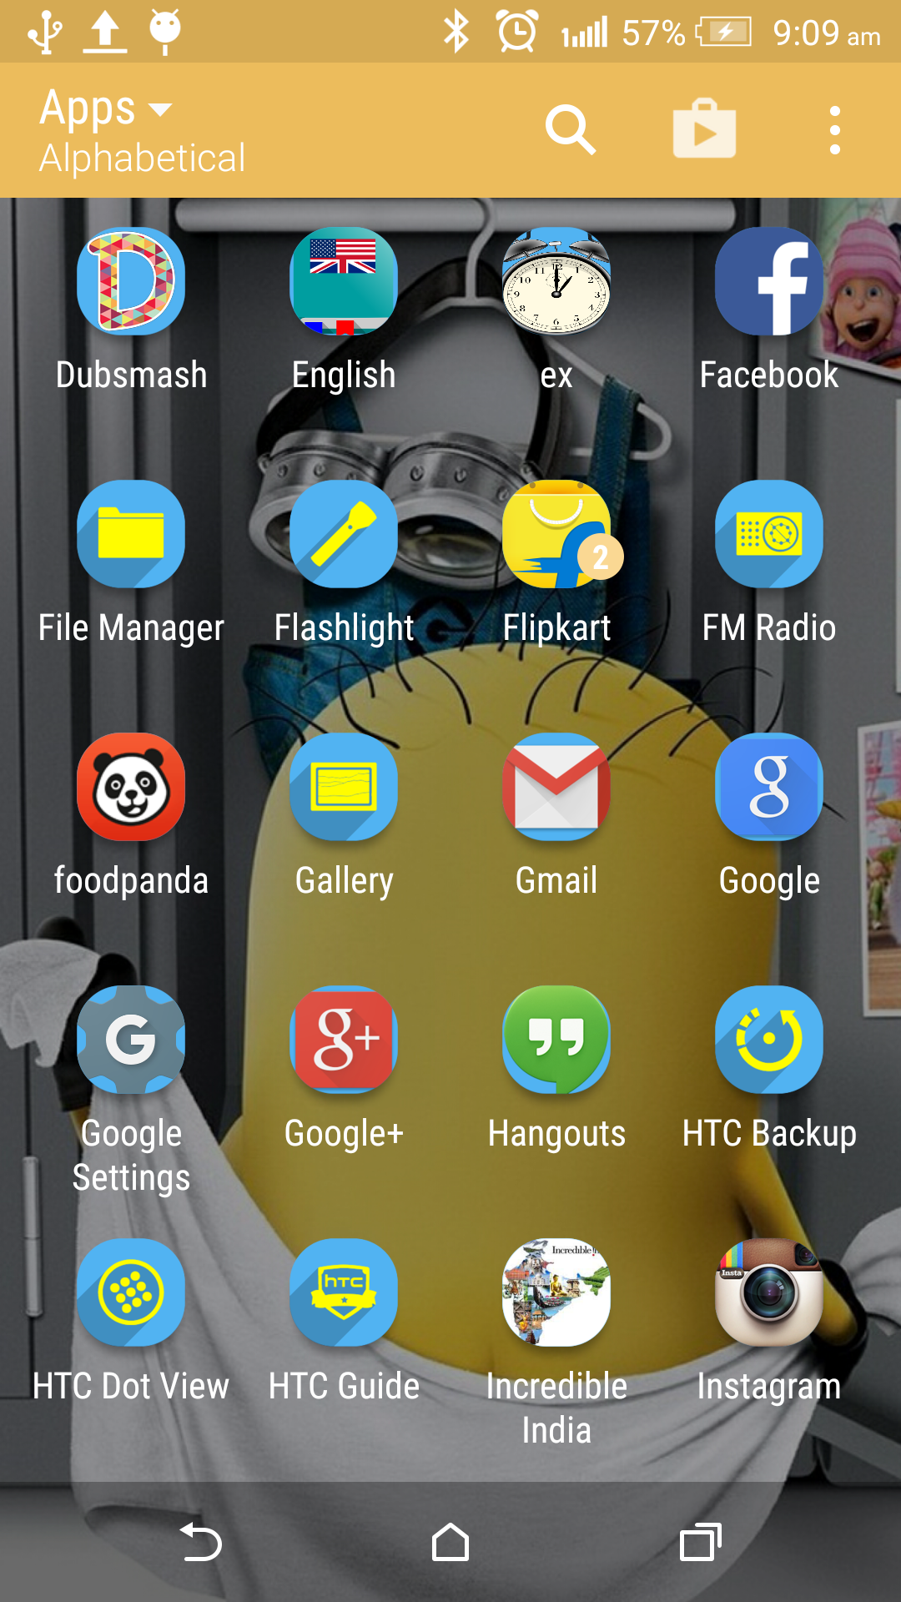

**Fig 6.1.1: Logo Screen:**

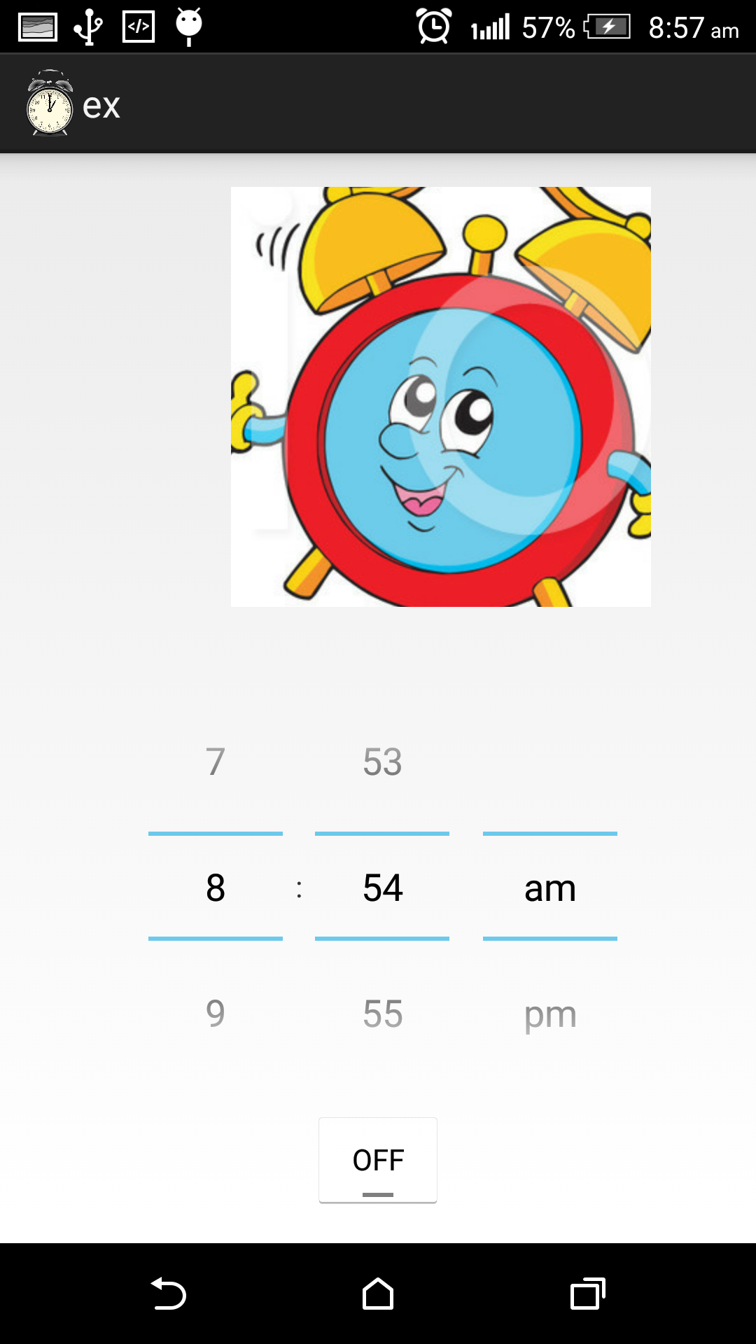

**Fig 6.1.2: Welcome Screen:**

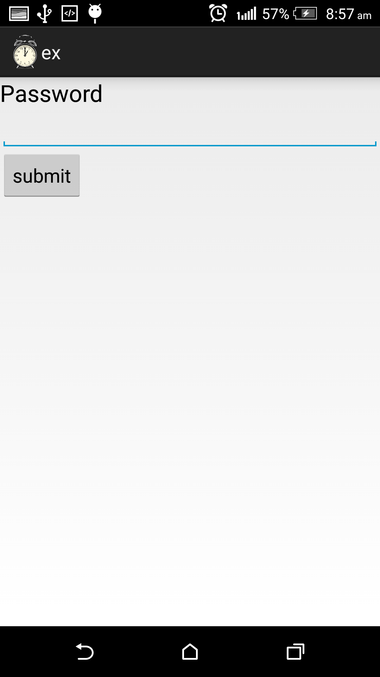

**Fig 6.1.3: User Screen**

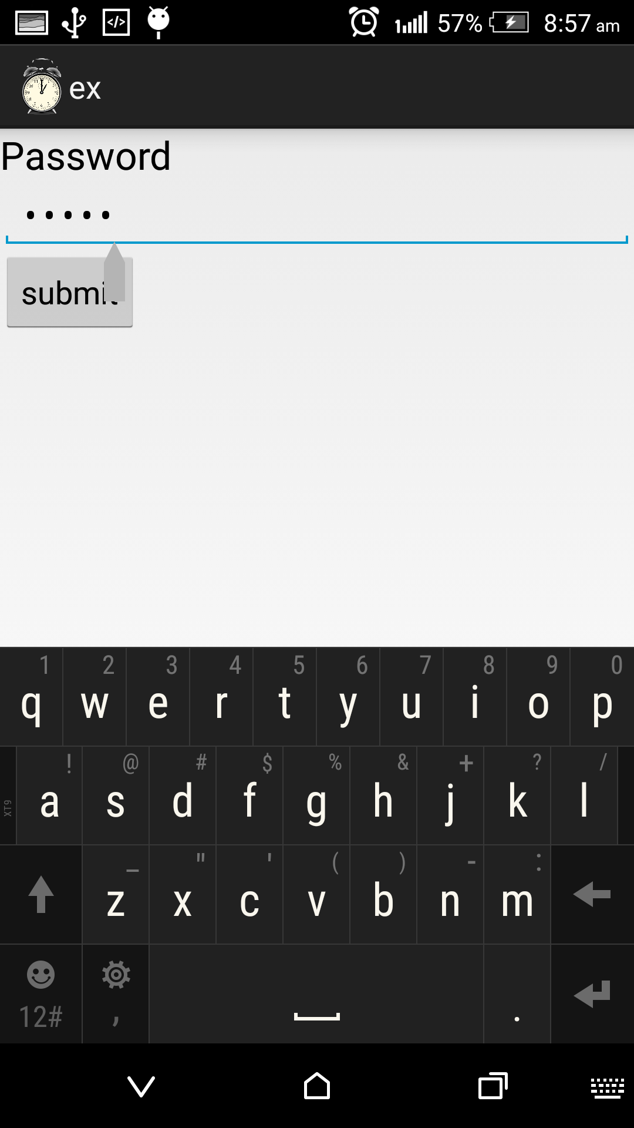

**Fig 6.1.4: Entering the password and submitting**

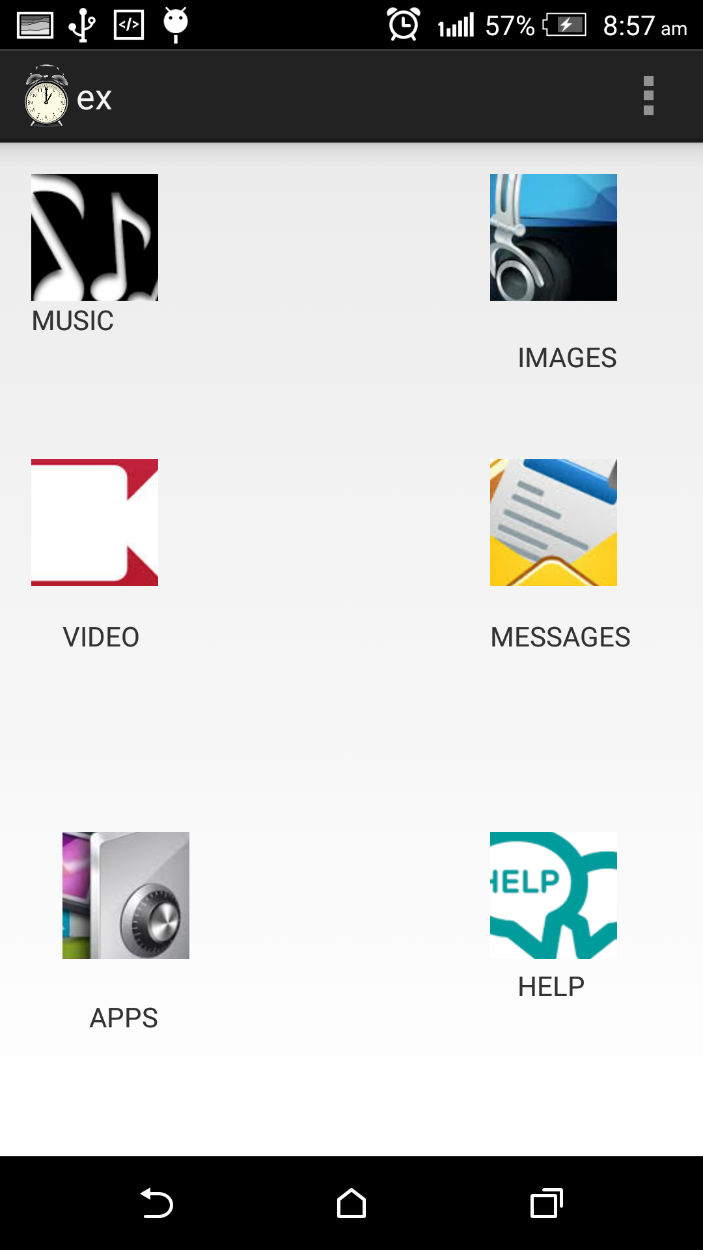

**Fig 6.1.5: Theme**

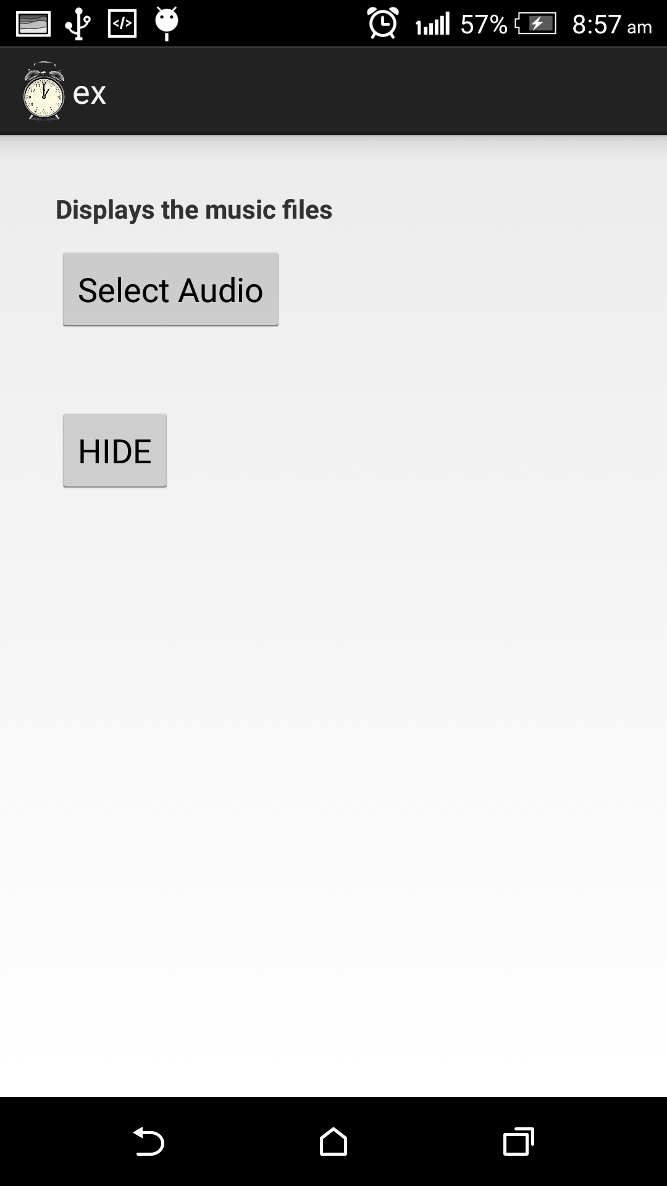

**Fig 6.1.6: Click on Select Audio Button**

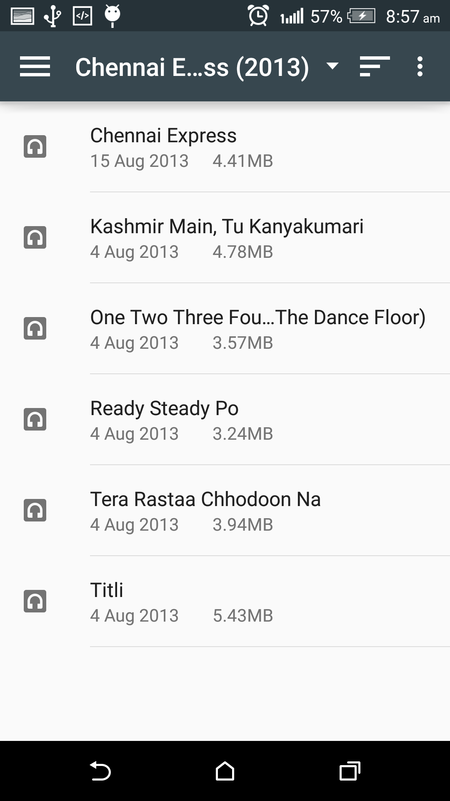

**Fig 6.1.7: List of Music Files**

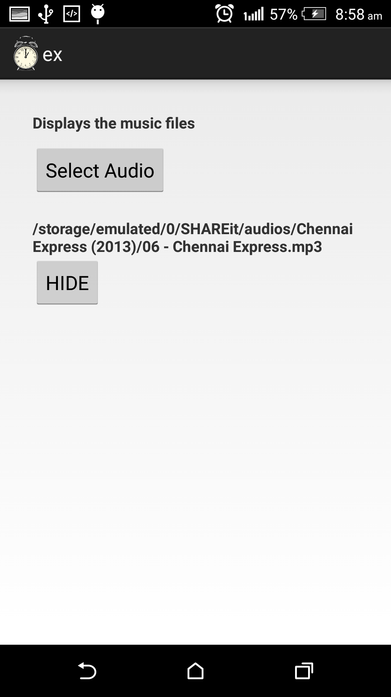

**Fig6.1.8: Select The File To Hide**

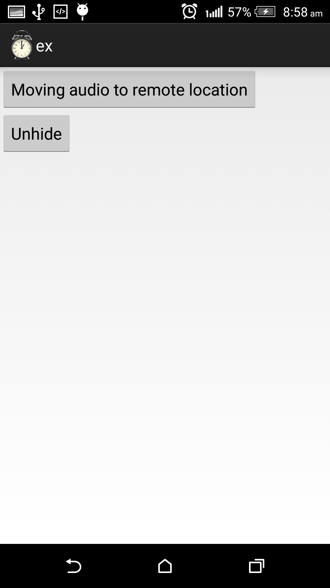

**Fig 6.1.9: Moving Audio To Remote Location**

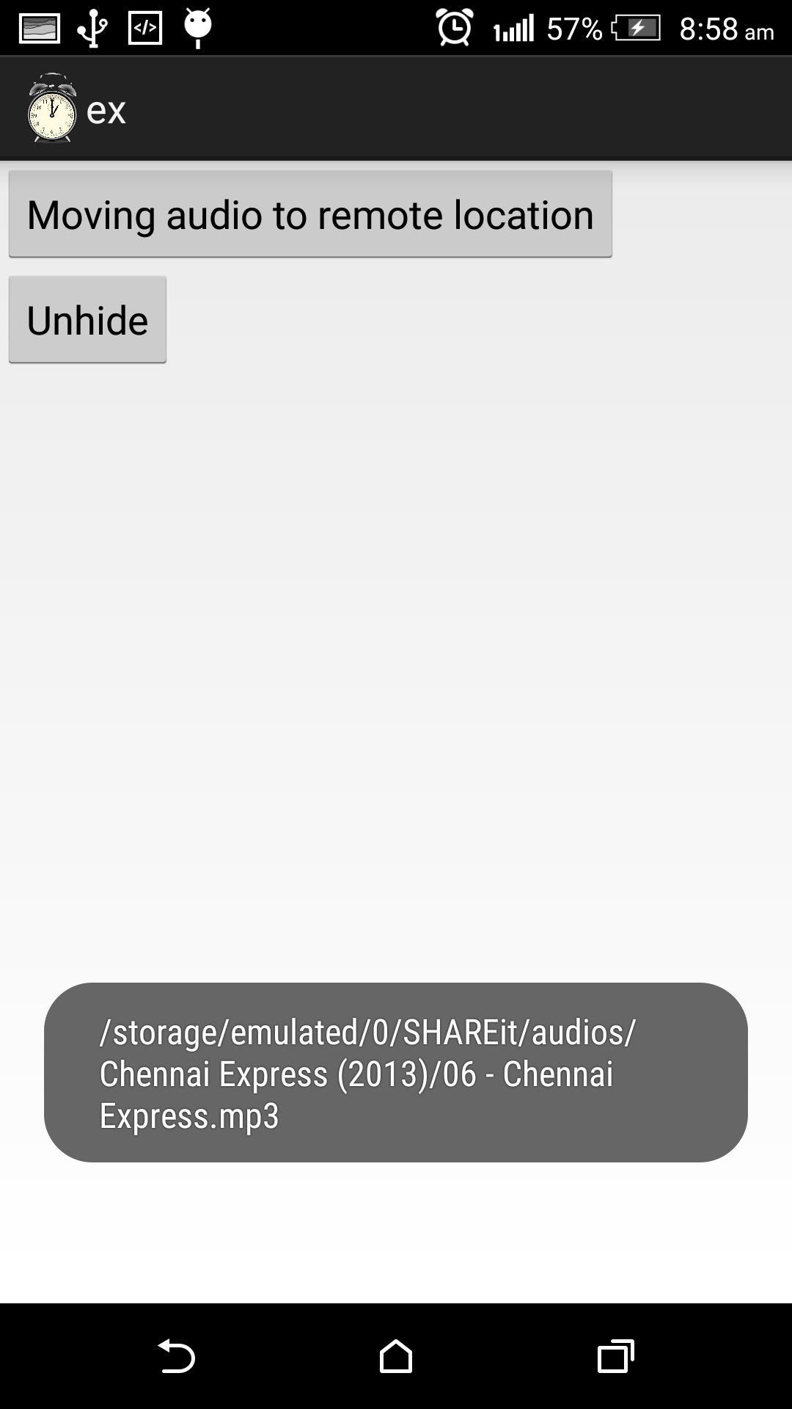

**Fig 6.1.10: Shows the Path of Remote Location**

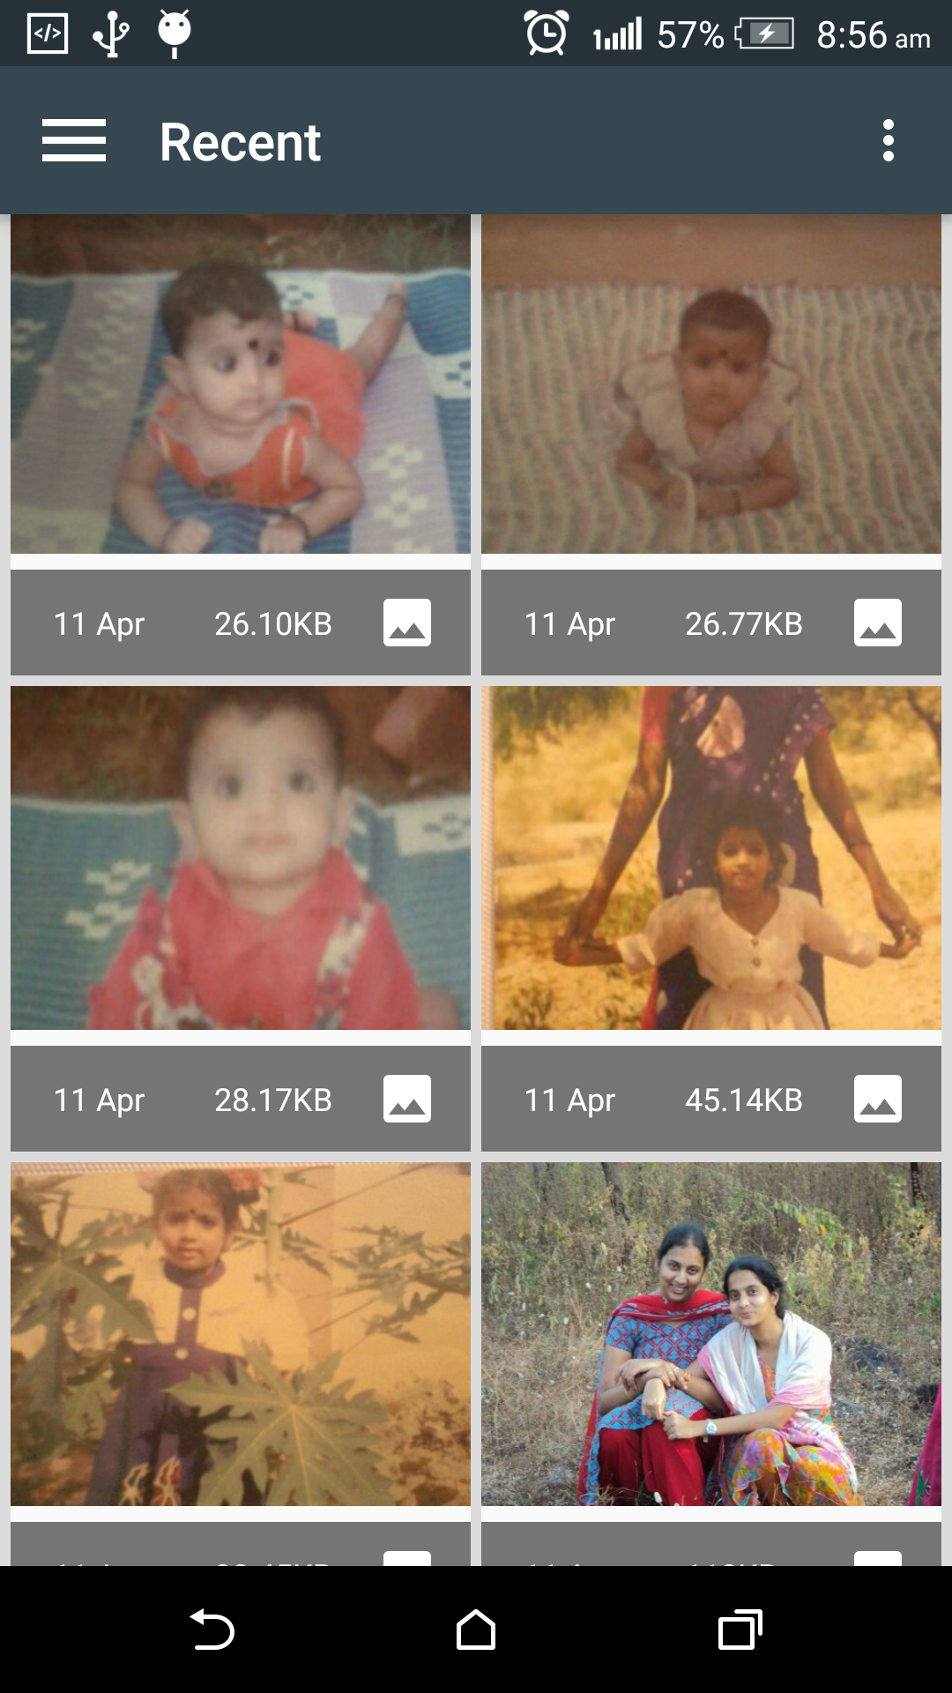

**Fig 6.1.11: Gallery**

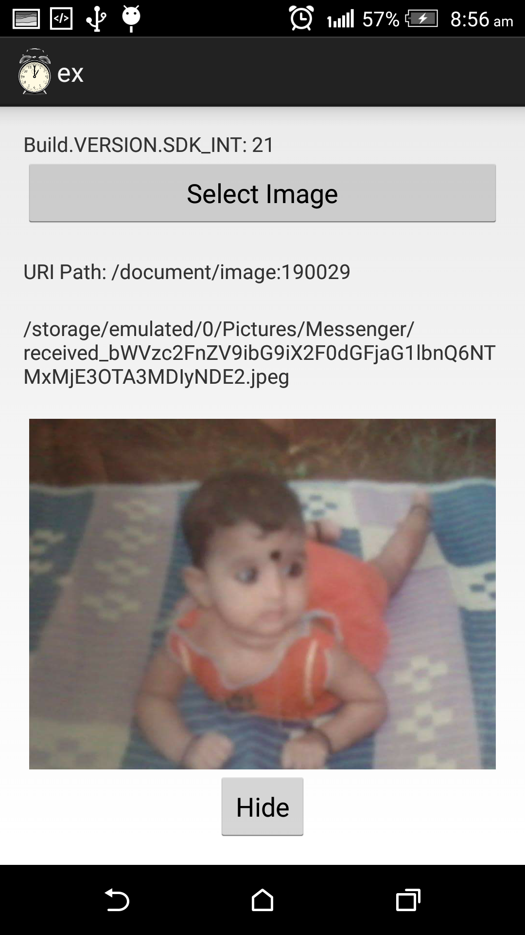

**Fig6.1.12: Select the Images from Gallery**

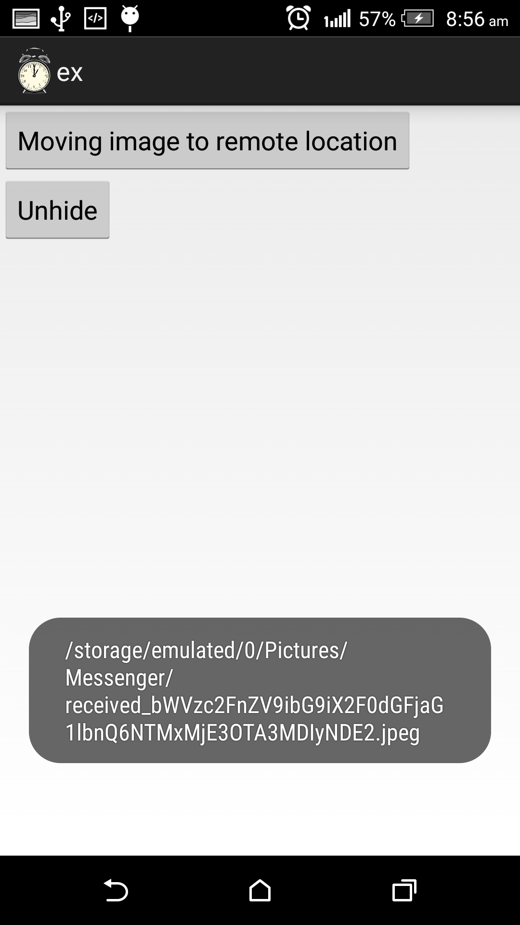

**Fig6.1.13: Moving images to remote location**

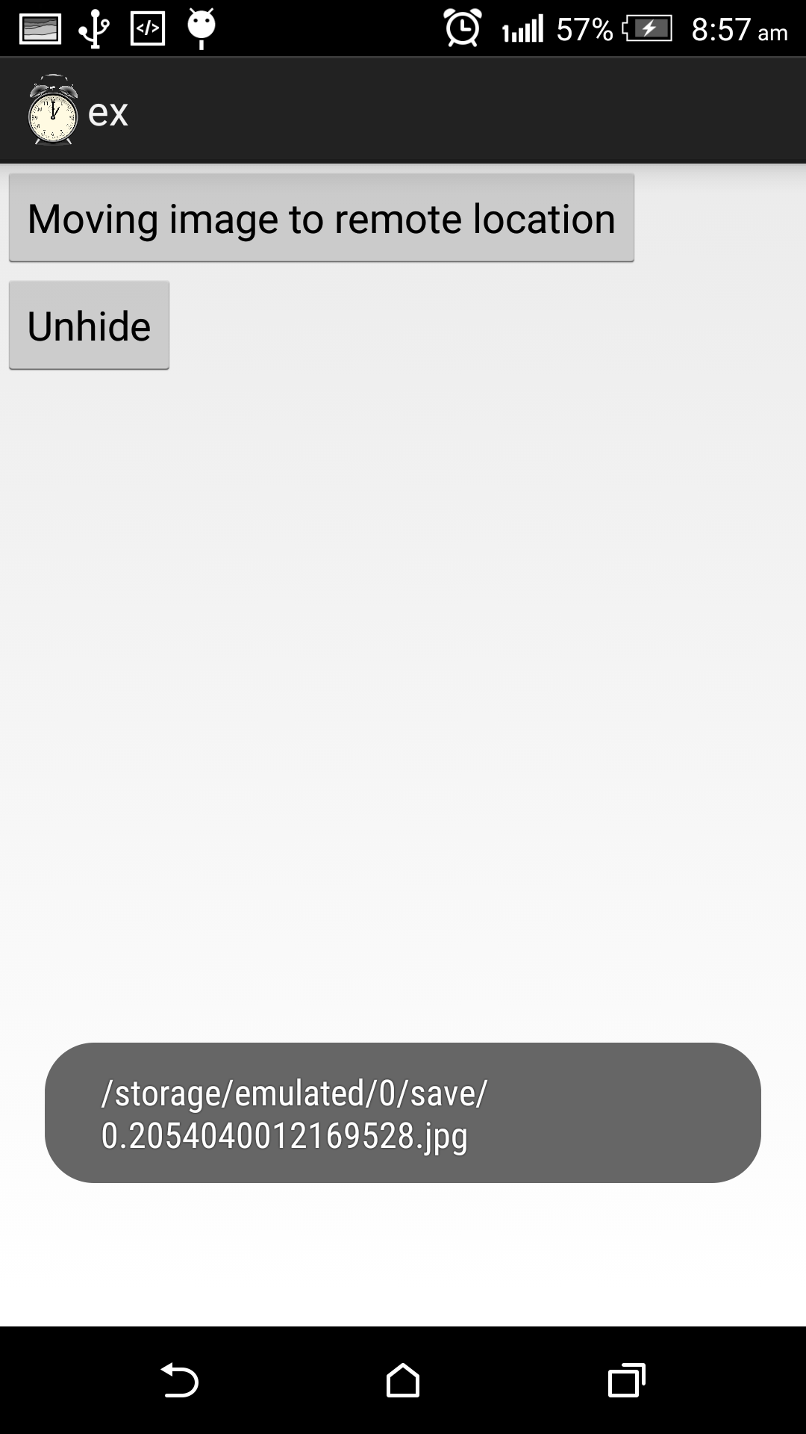

**Fig 6.1.14: Selected Image Saved**

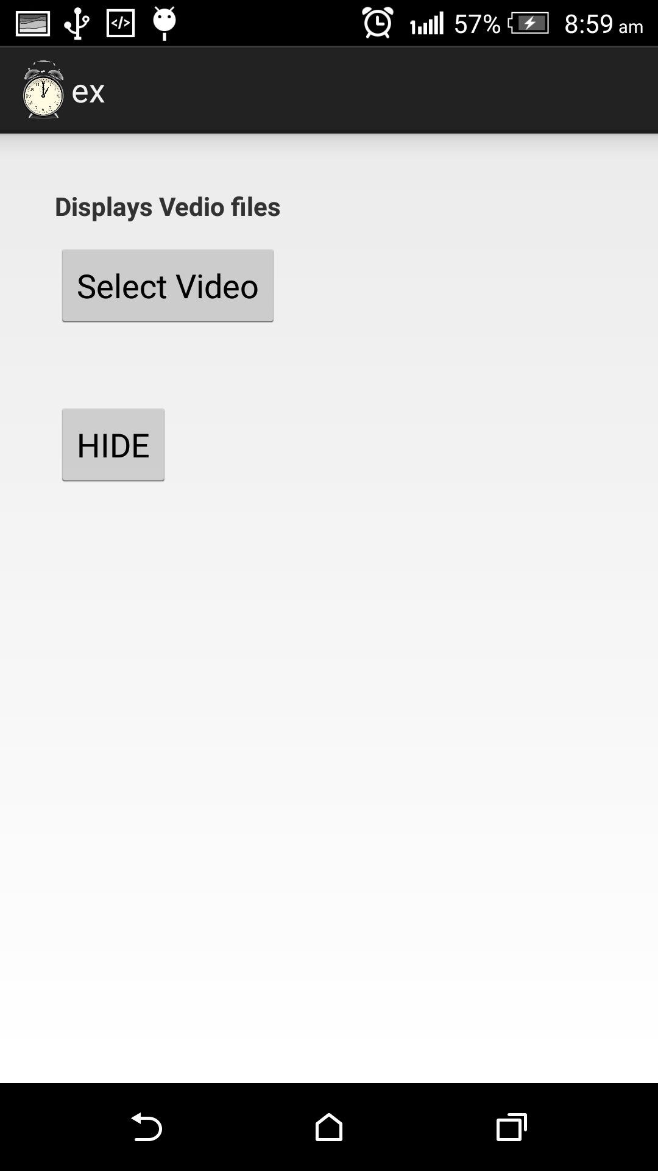

**Fig 6.1.15: Click on Select Vedio Files**

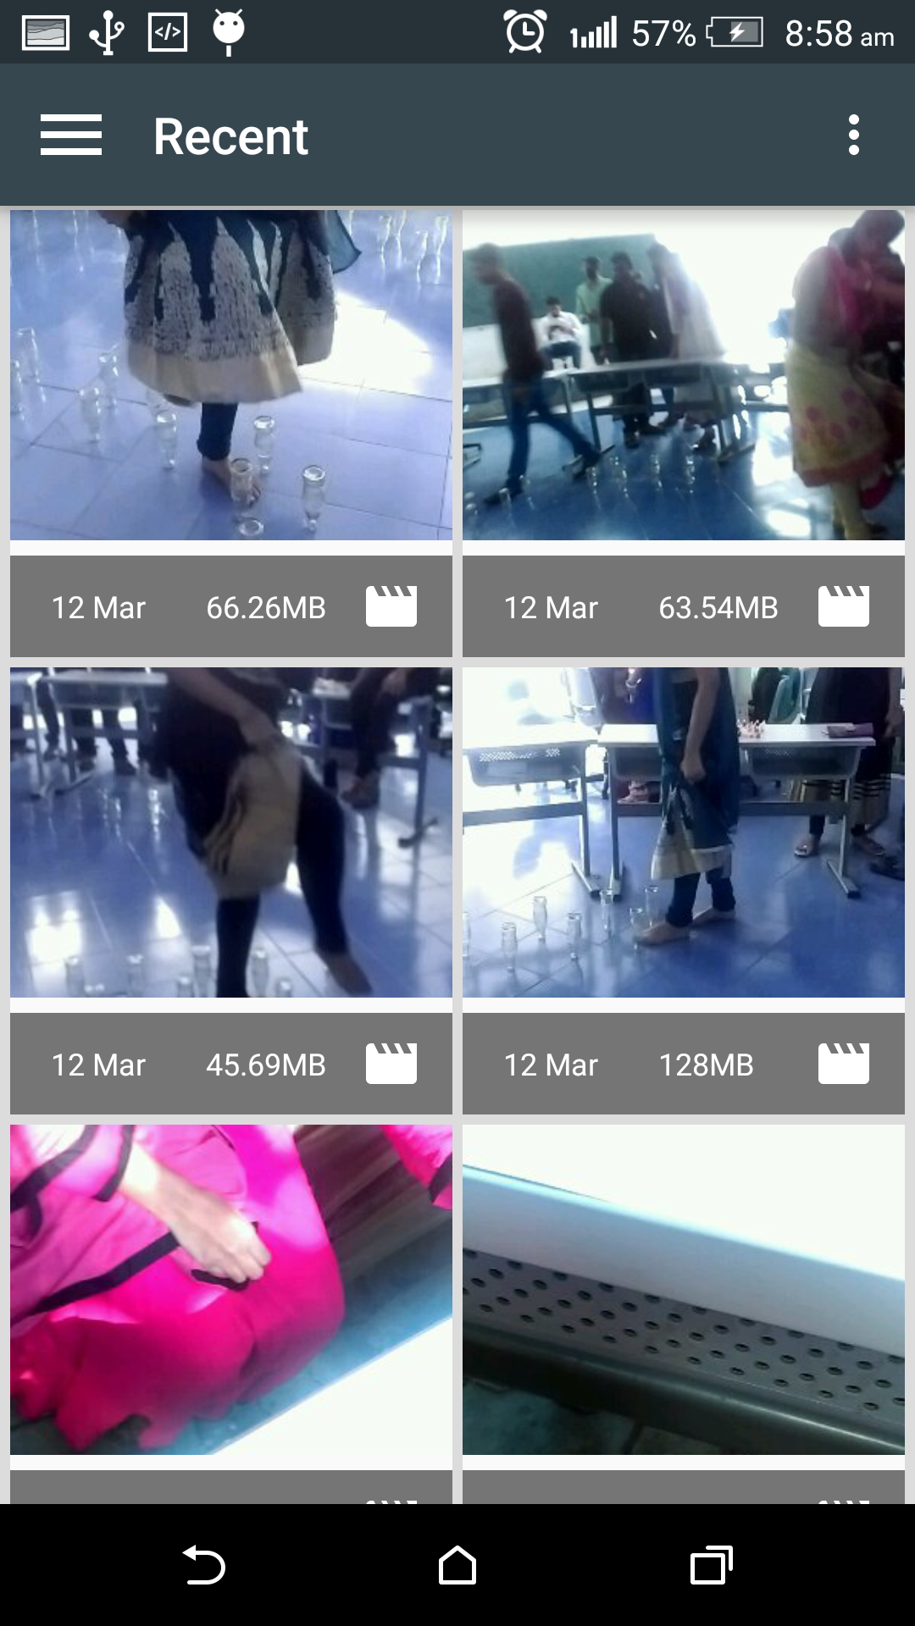

**Fig6.1.16: List of Video Files**

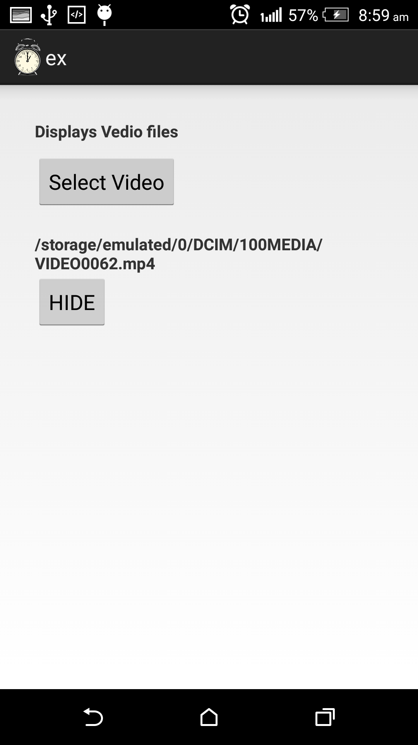

**Fig 6.1.17: Shows the Location of Image**

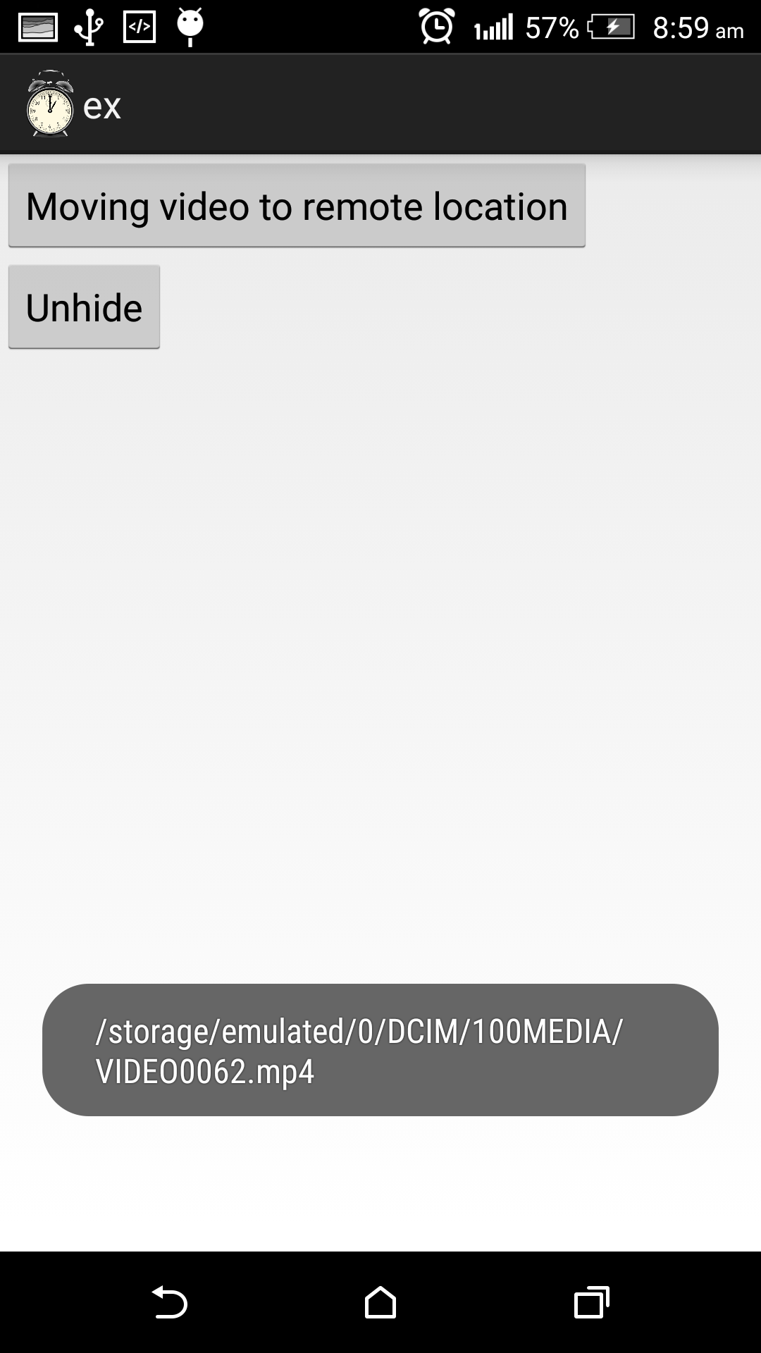

**Fig 6.1.18 Moving Video to Remote Location**

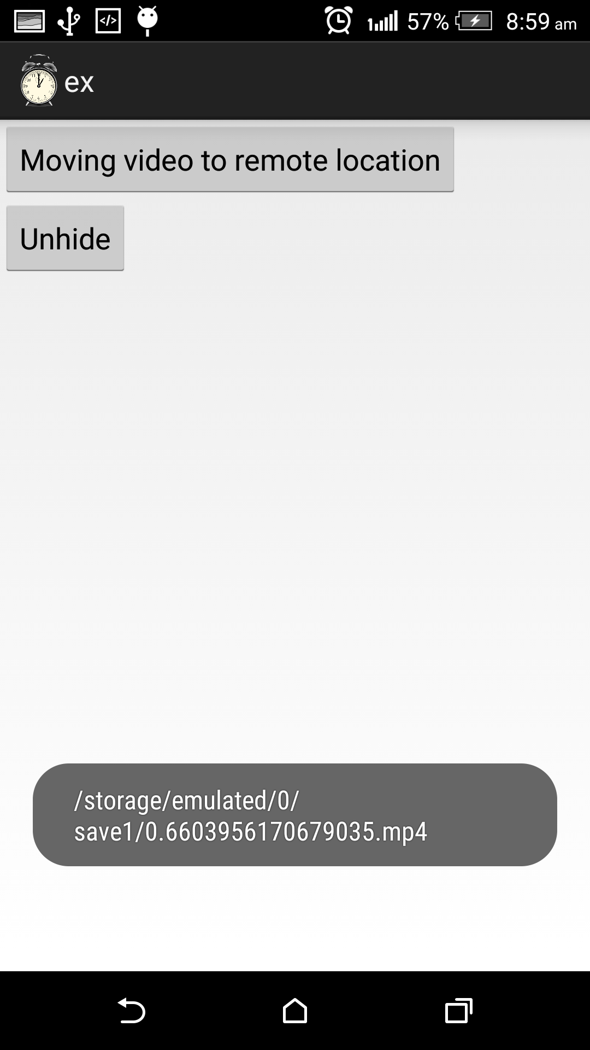

**Fig 6.1.19: Video Saved Succes fully**

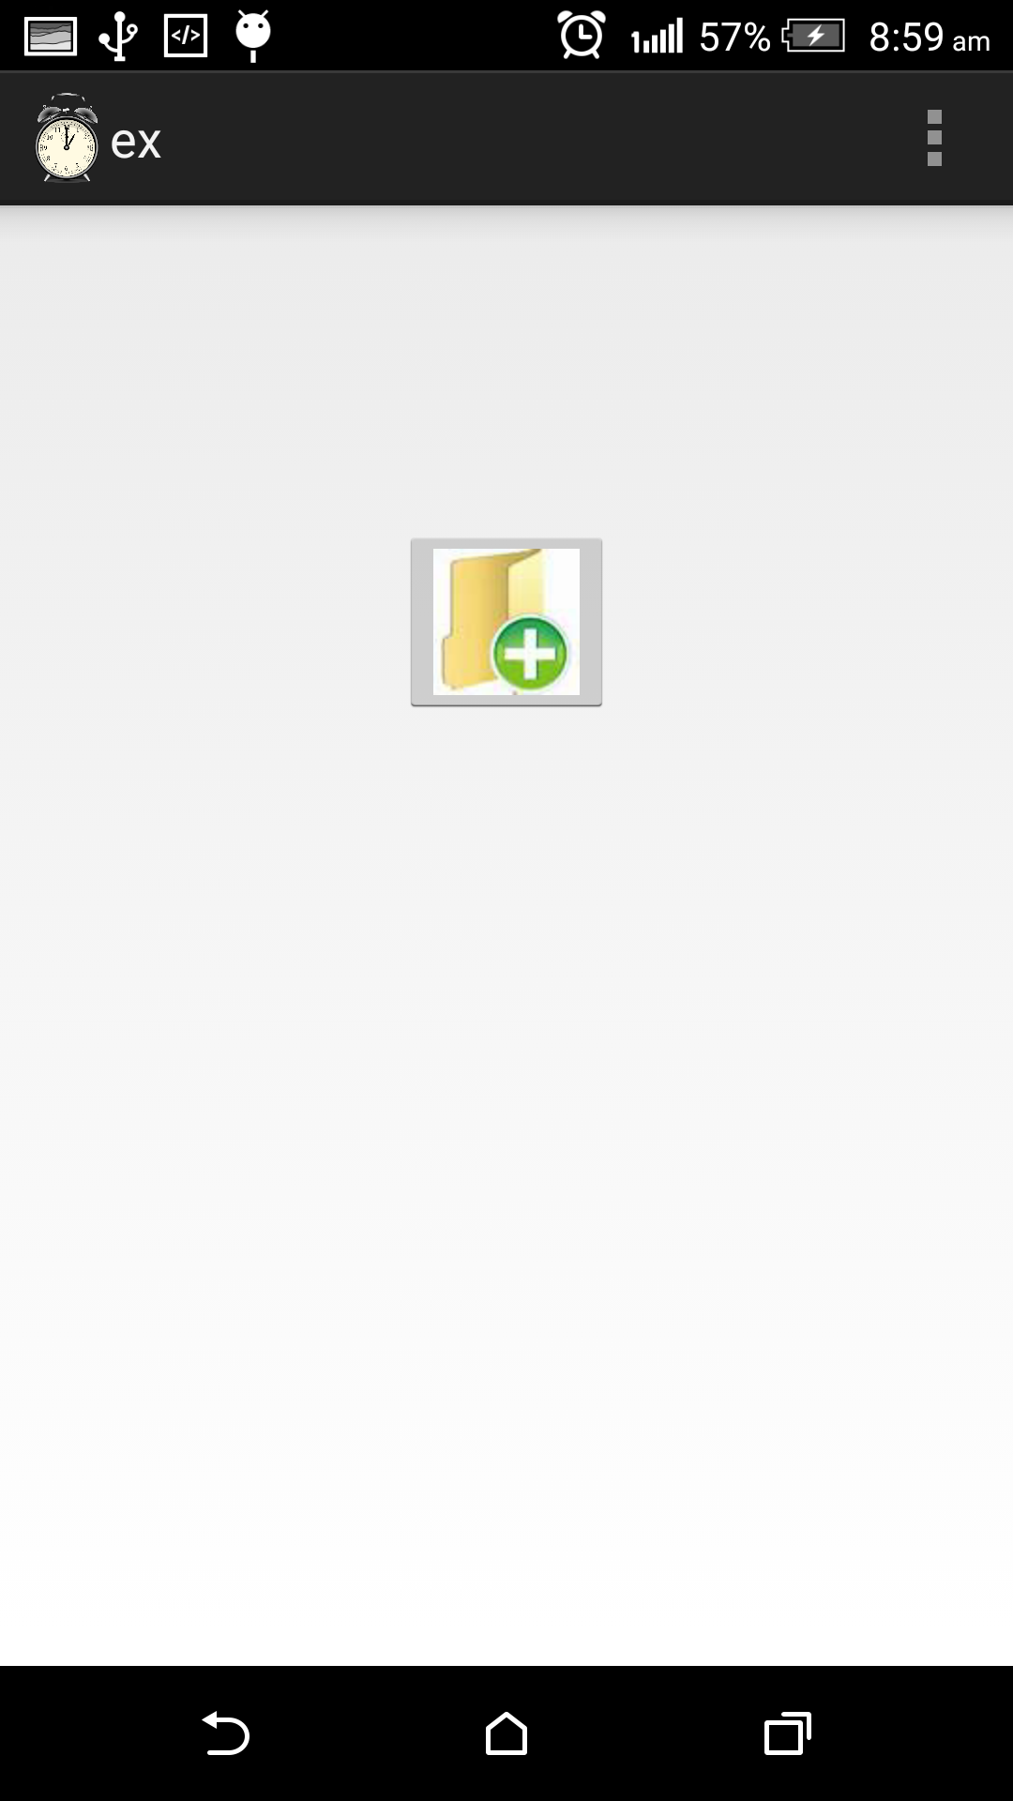

**Fig6.1.20: Click On the Following Buttons**

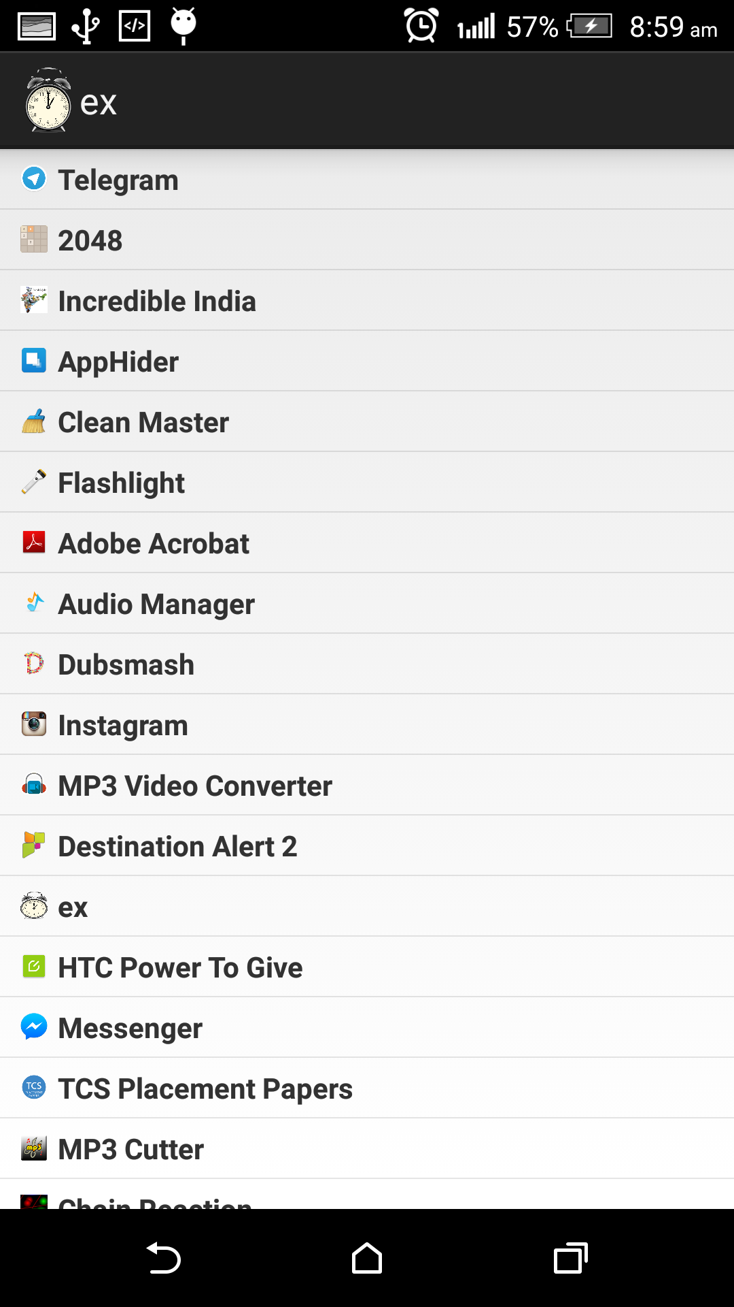

**Fig 6.1.21: Displaying the list of apps**

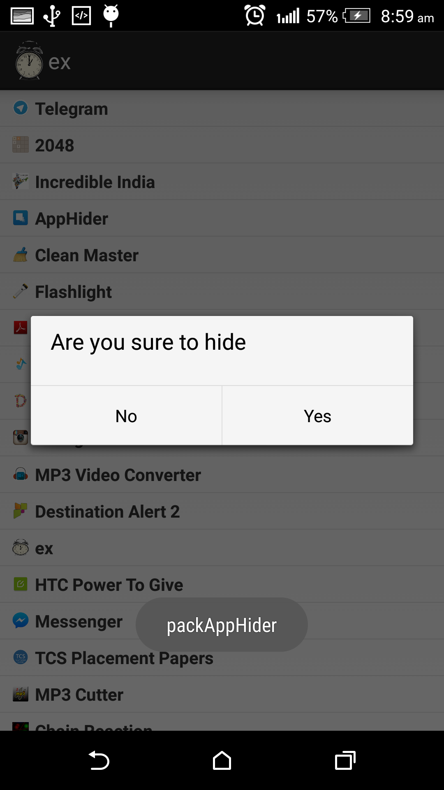

**Fig 6.1.22:shows the alert message**

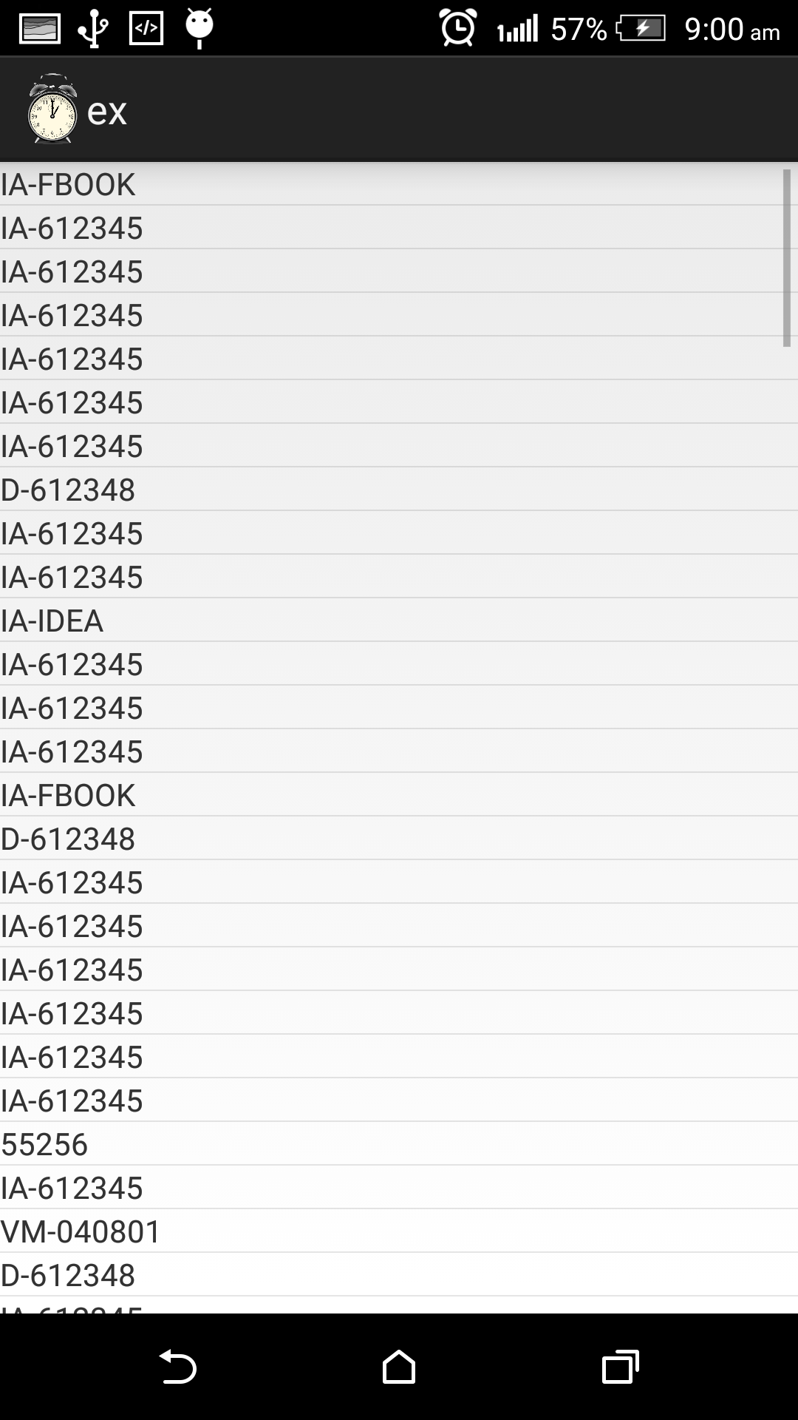

**Fig 6.1.23: Displays the numbers from where we receive messages**

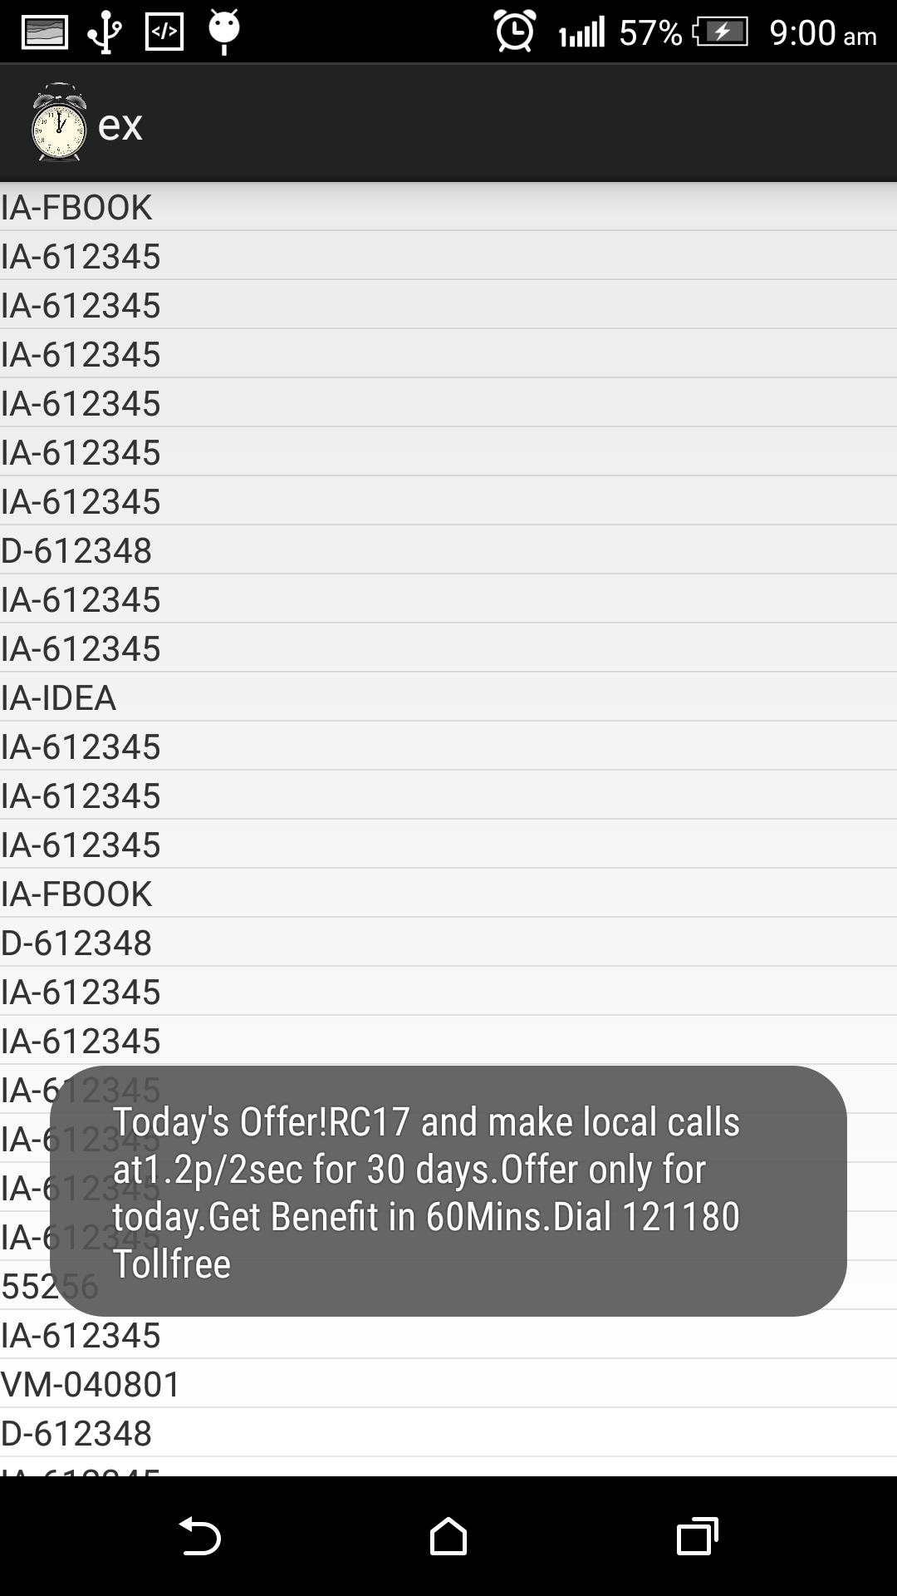

**Fig 6.1.24: Shows The Message Onclicking On The Number**

